European Type Jaw Crusher

Product Introduction:
Liming Road and Bridge Heavy Industry is the leading enterprise of rock & mineral processing equipment in the world. Since the end of the 20th century, we've installed about thousands of crushing machines all over the world. Nowadays, JCE series crusher of European style has already become the most popular equipment in the world without controversy. Considering crushing efficiently hard and abrasion proof stuff, JCE series crusher adopted international advanced technology is the first choice.
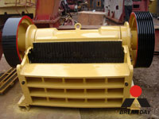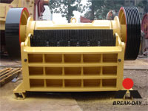

The features of JCE series crusher:
1. World-level manufacturing technology is adopted, perfect raw material is selected.
2. More advanced movable jaw assembly lengthens life of JCE.
Movable jaw assembly, composed of cast steel structure with high-quality, is driven by two big flying wheels which are also made from cast steel. Moreover, heavy eccentric axle is processed by forged mold. All of these make the JCE series crusher extremely reliable.
3. Integral cast steel structure is adopted for bearing seat.
Integral cast steel bearing matches well with the crusher frame, at the same time, radial strength of the bearing seat is highly strengthened. However, the separate bearing seat does not have this advantage.
4. Finite element analysis technology is adopted to make the crusher more stronger.
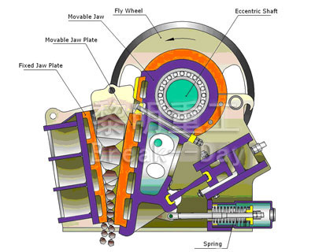
5. Crusher chamber adopts "V" structure which could make actual feed width comply with the nominal one.
6. Adjustment of the discharge part is more convenient.
Discharge part of JCE series crusher is installed wedge block, which makes discharge much simpler, safer and faster than the spacer on old style crusher.
7. Bearing with larger specification and stronger capacity are used.
8. A newly designed tooth-shape jaw plate, makes the available area of jaw plate longer, and enhances the capacity.
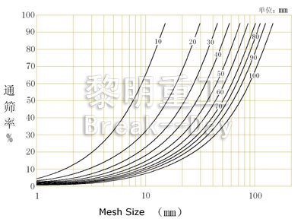

Technical Data:
Model |  | JC180×1300 | JC250×1000 | JCE250×1300 | JCE400×600
Opening Size (mm) |  | 180×1300 | 250×1000 | 250×1300 | 400×600
Max. Feed Size (mm) |  | 150 | 220 | 220 | 350
Discharge Opening Range (mm) |  | 10-30 | 20-40 | 70-100 | 35-85
Shaft Speed (r/min) |  | 320 | 330 | 290 | 250
Capacity (t/h) |  | 12-35 | 15-50 | 26-85 | 15-70
Motor | Model | Y225M-6 | Y225M-6 | Y250M-6/Y280S-6 | Y225M-6
Motor | Power (kW) | 30 | 30 | 37/45 | 30
Motor | Speed (r/min) | 980 | 980 | 980 | 980
Dimension (mm) (L×W×H) |  | 1320×2150×1175 | 1400×1850×1310 | 1450×2150×1175 | 1920×1460×1840
Weight (kg) |  | 6000 | 5600 | 6800 | 7000
Notice: Any change of European Type Jaw Crusher technical data shall not be advised additionally.

Contact Us:
Address: No. 15, Dingxiangli Road, National HI-TECH Industry Development Zone, Zhengzhou, China.
Postcode: 450001
Tel: 0086-371-67992899 67371699 67999318 67996989
Fax: 0086-371-67992699
Email: Break-day@break-day.com
MSN Online: MiningMachine@hotmail.com
MSG Online: Summer_8001@yahoo.com
Skype: miningmachinery

