Grinding Production Line
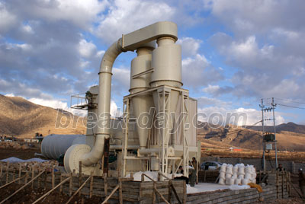

Grinding Production Line:
Grinding plant consists of mainframe, speed reducer, powder separator, blower, bag filter, pipes, cyclone, motor, etc. The peripheral equipment is jaw crusher, bucket elevator, feeder, hopper, electric control panel, etc. Break-day grinding Mill can grind all kinds of non-flammable and non-explosive minerals with Moh’s hardness lower than 9 and humidity less than 6%，and is widely used in metallurgy, construction of building materials, chemical industry, mining industry, etc.
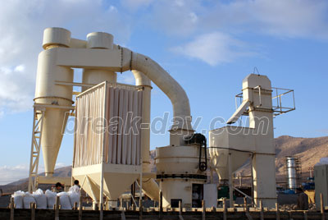

Working Principle:
Large materials are crushed by Jaw crusher to the needed sizes firstly, then the materials are elevated to storage hopper by bucket elevator, thirdly, the materials are fed into the grinding chamber for grinding by vibrating feeder evenly and continuously. The powder after grinding goes upwards together with the airflow, after separated by powder separator, the powder which can meet the fineness requirement enters into the cyclone powder collector through pipe together with the airflow, and then is discharged from the discharge valve as final product. The airflow is sucked into centrifugal blower through wind recycling pipe at the upper part of cyclone powder collector. The mainframe is driven by the speed reducer through the central axis in the mill. The quincunx stand connects with the upper part of central axis, at the quincunx stand, rollers are set and by which the vibrating pivot formed. Below the quincunx stand and rollers is shovel system. Materials are fed into the space between turning rollers and shovels , and then are grinded by the pressure produced by turing rollers, thus powder is made.

Contact Us:
Address: No. 15, Dingxiangli Road, National HI-TECH Industry Development Zone, Zhengzhou, China.
Postcode: 450001
Tel: 0086-371-67992899 67371699 67999318 67996989
Fax: 0086-371-67992699
Email: Break-day@break-day.com
MSN Online: MiningMachine@hotmail.com
MSG Online: Summer_8001@yahoo.com
Skype: miningmachinery

