Hammer Crusher
The hammer crusher (hammer mill) crushes by the collisions between high-speed hammer and material, and the hammer crusher (hammer mill) has the features of simple structure, high reduction ratio, high efficiency, etc. The PC hammer crusher (hammer mill)is developed for both dry and wet crushing of brittle, medium-hard materials for the mining, cement, coal, metallurgic material, construction material, road building, and petroleum & chemical industries.
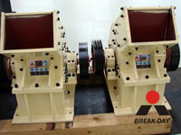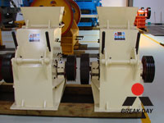

Operating principle of Hammer Crusher:
In the hammer mill machine, the motor drives the rotor to rotate at a high speed through the belt, and on the rotor there are series of hammers. When the materials get into the working area of hammers, the rotating hammers with high rotation speed are crushing them, the crushed products meeting the required size can be discharged by the outlet and become the final products, the large size products are brought back to the crushing area by the hammers for being re-crushed until they reached the required size.

Technical data:
Name | Model | Max feed size (mm) | Handling capacity (t/h) | Power of motor (kW) | Weight (t)
hammer crusher  (hammer mill) | PC400×300 | 30 | 5-8 | 11 | 1.5
hammer crusher  (hammer mill) | PC600×400 | 100 | 10-15 | 18.5 | 3
hammer crusher  (hammer mill) | PC800×600 | 150 | 20-25 | 55 | 7
hammer crusher  (hammer mill) | PC800×1000 | 280 | 20-50 | 110 | 12
Circuit Type  Hammer Mill | PCH0606 | 200 | 18-30 | 30 | 17
Circuit Type  Hammer Mill | PCH0808 | 250 | 30-50 | 45 | 29
Circuit Type  Hammer Mill | PCH1010 | 300 | 45-80 | 90 | 52
Notice: Any change of Hammer Crusher technical data shall not be advised additionally.

Contact Us:
Address: No. 15, Dingxiangli Road, National HI-TECH Industry Development Zone, Zhengzhou, China.
Postcode: 450001
Tel: 0086-371-67992899 67371699 67999318 67996989
Fax: 0086-371-67992699
Email: Break-day@break-day.com
MSN Online: MiningMachine@hotmail.com
MSG Online: Summer_8001@yahoo.com
Skype: miningmachinery

