HGM Three-Rings & Medium-Speed MicroPowder Mill
HGM series Three-ring & Medium-speed micro-powder mill is designed basing on our 20 years’ manufacturing experience, absorbing the Swedish advanced machine manufacturing techniques. It is a new type of mill for making super fine powder through more than 20 times of test and improvement. It is the latest type of product of micro-powder mill that leads the world tide.
HGM series three-ring medium speed micro-powder mill is designed to get fine and super fine powder. It is mainly used to process more than 200 kinds of non-inflammable, non-explosive and brittle materials with Moh’s hardness below 6 scale, such as calcite, chalk, limestone, dolomite, kaolin, bentonite, talc, mica, magnesite, illite, pyrophyllite, vermiculite, sepiolite, attapulgite, tablite, ceyssatite, barite, gypsum, alunite, black lead, fluorite, phosphate rock, potassium ore, floatstone etc. When HGM mills are used to process materials with Moh’s hardness between 4-6 scale, the service lifetime of easy-worn parts shall be shortened as it relies on the hardness of raw material.
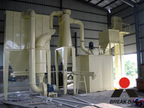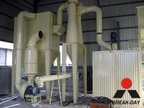

Working Principle:
The motor drives the main shaft and every turnplate through the reducer. The reducer drives dozens of rollers to rotate against race way of ring through pin. Small material crushed by hammer crusher is transported into hopper by elevator, and then vibrating feeder shall feed material to the central part of upper turnplate evenly. The material falls to circle under the centrifugal force and comes down to raceway of ring to be crushed into powder. After grinded in the first race way, the material goes to the second and third turnplate. The blower inhales the external air into the mill and carries the powder after third turnplate into powder-separator. Turbine in the separator makes the coarse powder drop down and regrinded and the fine powder shall go into cyclone powder collector together with air current and go down through discharge valve as final product; at the same time, air current with a little dust goes out through blower and muffler after purified by filter.
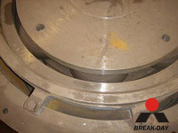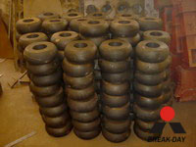

Advantage and Characteristics:
Three-Ring & Medium-Speed MicroPowder Mill has high efficiency and low cost. Its capacity is raised by 40% compared with airflow mill and mix mill on the condition that the materials, the drive and the fineness of the final powder are the same. The life span of tear & wear parts is more than that of straight impact crusher and turbine mill under the circumstance of same materials and fineness of the final powder. Usually, its life span is more than one year. There is no rolling bearing and screw in the grinding cavity, so as to avoid the damage to the machine caused by tear & wear of bearing and seals and the looseness of screws. The fineness of powder can reach ≦5μm with d97 once.

Technical Data:
Model | HGM60 | HGM80 | HGM100
Roller number | 15 | 21 | 27
Diameter (mm) | Φ600 | Φ800 | Φ1000
Ring number | 2 | 2 | 2
Main unit speed(mm) | 235 | 235 | 235
Max. feeding size(mm) | 10 | 10 | 10
Final size (mesh) | 325-2500 | 325-2500 | 325-2500
Capacity (kg/h) | 350-2500 | 600-4000 | 900-6000
Overall dimension (m) | 10×2×5.5 | 12.4×2.5×5.8 | 14.5×3.8×6.3
Notice: Any change of Three-Rings & Medium-Speed MicroPowder Mill technical data shall not be advised additionally.

Contact Us:
Address: No. 15, Dingxiangli Road, National HI-TECH Industry Development Zone, Zhengzhou, China.
Postcode: 450001
Tel: 0086-371-67992899 67371699 67999318 67996989
Fax: 0086-371-67992699
Email: Break-day@break-day.com
MSN Online: MiningMachine@hotmail.com
MSG Online: Summer_8001@yahoo.com
Skype: miningmachinery

