Impact Crusher
Impact crusher is new product designed by our company after absorbing the advanced technology home and abroad. This kind of crusher can crush many kinds of materials with max feed size less than 500mm and crushing strength less than 360 MP. It has the features of high ratio of crushing, high efficiency of crushing, easy to maintenance, etc. The final products are with cubic shapes and are the ideal equipments for construction the highway and water and electricity construction. In addition, impact crushers are more suitable to process granite, limestone, bank gravel etc. in the area of highway construction, water conservancy project and architecture.

Characteristics:
Hammer is made of high chrome; liner board is made of wearable materials;
Specially designed tooth impact plate;
More suitable for crushing hard rock, high efficiency, low consumption;
Final products is cubic, discharge opening is adjustable;
Make the crushing flow chart simple.
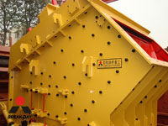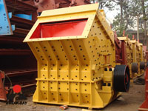

Technical Data:
Model | Size of rotor (mm) | Feed opening (mm) | Max. feed size (mm) | Capacity (t/h) | Power of Motor (kW) | Weight (t)
PF1007 | Φ1000×700 | 400×730 | 300 | 15-30 | 37 | 6
PF1010 | Φ1000×1050 | 400×1080 | 350 | 50-80 | 75 | 12.5
PF1210 | Φ1250×1050 | 400×1080 | 350 | 70-130 | 110 | 16.5
PF1214 | Φ1250×1400 | 400×1430 | 350 | 90-180 | 132 | 19
PF1315 | Φ1320×1500 | 860×1520 | 500 | 120-250 | 200 | 24
PF1320 | Φ1320×2000 | 860×2030 | 500 | 160-350 | 260 | 27
Notice: Any change of Impact Crusher technical data shall not be advised additionally.

Contact Us:
Address: No. 15, Dingxiangli Road, National HI-TECH Industry Development Zone, Zhengzhou, China.
Postcode: 450001
Tel: 0086-371-67992899 67371699 67999318 67996989
Fax: 0086-371-67992699
Email: Break-day@break-day.com
MSN Online: MiningMachine@hotmail.com
MSG Online: Summer_8001@yahoo.com
Skype: miningmachinery

