Mobile Crushing & Screening Plant
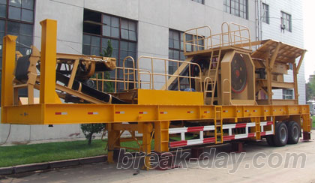
Mobile crushing plant, a new designed rock crushing & screening plant, which is flexible, convenient and strong in mobility, so it can save a large construction capital and relocation. Raw Materials can be broken at the local place without being transported again, and also can be moved with the further exploitation of the raw material, which saves a large number of transportation cost. Break-day corporation specializes in producing crusher, screen, transportation, other rock breaking, minerial processing equipment. On the basis of professional technology, we optimize and introduce two large and three small series of crushing and screening equipment. The mobile series is tracked crushing plant, and the portable series is tyred crushing plant. Each large series is divided into three series: rough, medium and fine crushing and screening mobile plant. Therefore, it can fully adapt to the various mobile crushing and screening spots, and creates more new business opportunities for customers while reducing cost of production.

Features:
1. Complete plant;
All the machines are installed on the trailer, Occupation space is saved, Working efficiency is enhanced;
2. Strong flexibility;
It can be moved from one place to another place;
3. High efficiency;
4. Great work and easy maintenance.
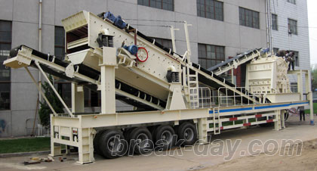
Coarse crushing & screening plant model:
YG938E69
YG1142E710
YG1349E912
Medium crushing & screening plant model (Impact crusher as secondary crusher):
Y3S1548F1010
Y3S1848F1210
Y3S1860F1214
Y3S2160F1315
Medium crushing & screening plant model (Cone crusher as secondary crusher):
Y3S1548Y55
Y3S1848Y90
Y3S1860Y160
Y3S2160Y220

Note:
1. The above model is elementary mobile crushing plant;
2. We can produce the crushing & screening plant according to customers' requirement.

Contact Us:
Address: No. 15, Dingxiangli Road, National HI-TECH Industry Development Zone, Zhengzhou, China.
Postcode: 450001
Tel: 0086-371-67992899 67371699 67999318 67996989
Fax: 0086-371-67992699
Email: Break-day@break-day.com
MSN Online: MiningMachine@hotmail.com
MSG Online: Summer_8001@yahoo.com
Skype: miningmachinery

