Sand Making & Washing Plants
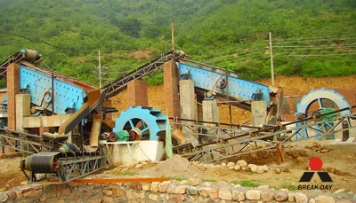

Sand Making & Washing Production Line:
Henan Liming Road & Bridge Heavy Industry Co., Ltd. manufactures various equipments for a whole set of sand-making production line, and provides superior technical support for customers. The whole sand-making production line consists of vibrating feeder, jaw crusher, VSI vertical shaft impact crusher (sand-making machine), vibrating screen, sand-washing machine, belt conveyor, electric control system, etc. We design different production lines ranging 50 t/h to 500 t/h. We have been researching the sand-making machine for years, and we have made it part of the production line. The whole set of sand-making production line designed by our company is suitable to crush the hard limestone, granite, basalt, gravel, slag, etc. and artificially sand making for hydroelectric power, building material, high way, city construction, etc. Different models of machines are combined to meet different customers’ different demands according to different craft requirements.

Process of the Production Line:
The raw material is transferred to jaw crusher for primary crushing by vibrating feeder, then the crushed material is transferred to sand-making machine through belt conveyor for secondary crushing. The materials crushed will be transferred to the vibrating screen. The material with suitable size will be transferred to sand washing machine, after being washed, then clean final products will be discharged. The other material with unsuitable size will be screened from vibrating screen, then will be transferred to the sand-making machine, this forms a closed and manifold cycles.
Sizes of final products will be according to our customers' requirements. If it is the dry process, the classifier and duster will be attached according to customers' requirements.

Contact Us:
Address: No. 15, Dingxiangli Road, National HI-TECH Industry Development Zone, Zhengzhou, China.
Postcode: 450001
Tel: 0086-371-67992899 67371699 67999318 67996989
Fax: 0086-371-67992699
Email: Break-day@break-day.com
MSN Online: MiningMachine@hotmail.com
MSG Online: Summer_8001@yahoo.com
Skype: miningmachinery

