Stone Crushing & Screening Plants
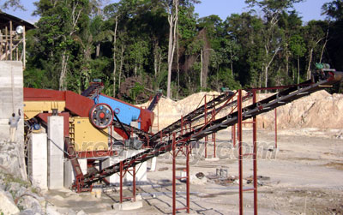

Stone Production Line:
Henan Liming Road & Bridge Heavy Industry Co., Ltd. manufactures various equipments for a whole set of stone production line, and provides complete technical support for customers. The whole production line consists of vibrating feeder, jaw crusher, impact crusher, vibrating screen, belt conveyor, electric control, etc. We design different production lines ranging 50 t/h to 500 t/h by combining different models of equipment which can match cone crusher, deduster, etc. If necessary to satisfy different customers’ technological requirements. It is widely used for crushing hard limestone, granite, basalt, gravel, metallurgic slag, etc. Or artificial sand making for hydroelectric power, building material, high way, city construction, etc. Different models of machines are combined to meet different customers' different demands according to different craft requirements.
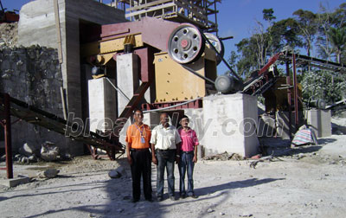

Process of the Production Line:
Big size stones are transferred to primary crusher through vibrating feeder from hopper for first crushing, then the crushed materials are transferred to impact crusher through belt conveyor for secondary crushing. The materials crushed will be transferred to the vibrating screen, and separated to different sizes. The aggregate with suitable size will be transferred to the final product pile and aggregate with unsuitable size will be transferred to the impact crusher for re-crushing. This forms a closed and manifold cycles. The sizes of final products will be graded and separated according to customers' requirements, and the duster will be attached for the sake of environment protection.

Contact Us:
Address: No. 15, Dingxiangli Road, National HI-TECH Industry Development Zone, Zhengzhou, China.
Postcode: 450001
Tel: 0086-371-67992899 67371699 67999318 67996989
Fax: 0086-371-67992699
Email: Break-day@break-day.com
MSN Online: MiningMachine@hotmail.com
MSG Online: Summer_8001@yahoo.com
Skype: miningmachinery

